HOSPITAL MANAGEMENT SYSTEM

MADE BY–YOGESH KUMAR

|  |  |  |
| --- | --- | --- |
| Sr No. | Topic | Page No. |
| 1 | Case Study | 3 |
| 2 | Steps | 4-5 |
| 3 | Software used | 6 |
| 3 | Database | 7-8 |
| 4 | Project Detail+ | 9 |
| 5 | Login Form | 10 |
| 6 | Accounts Form | 11 |
| 7 | Patient Main Menu | 12-13 |
| 8 | Insert Patient Record | 14-16 |
| 9 | Update Patient Record | 17-20 |
| 10 | Delete Patient Record | 21-24 |
| 11 | Show Patient Table | 25-27 |
| 12 | Generate Bill Form | 28-30 |
| 13 | Doctor Main Menu | 31-32 |
| 14 | Insert Doctor Record | 33-36 |
| 15 | Update Doctor Record | 37-40 |
| 16 | Delete Doctor Record | 41-43 |
| 17 | Show Doctor Table | 44-46 |

**Case Study**

Hospital are the essential part of our life, providing best medical facilities to people suffering from various ailments, which may be due to change in climatic conditions, increased work-load, emotional trauma stress etc. It is necessary for the hospital to keep track of its day-to-day activities& records of its patient, doctor and other staff personnel that keep the hospital running smoothly and successfully.

## But keeping track of all the activities and their records on paper is very cumbersome and error prone. It also is very inefficient and a time consuming process. Observing continuous increase in population and number of people visiting the hospital. Recording and maintaining all these records is highly unreliable, inefficient and error-prone. It is also not economically & technically feasible to maintain these records on paper.

Thus keeping the working of the manual system as the basis of our project. We have developed an automatic version of the manual system, named as” Hospital management system”.

The main aim of our project is to provide paperless hospital up to 90%. It also aims at providing low-cost reliable automation of the existing systems. The system also provides excellent security of data at every level of user-system interaction and also provides robust & reliable storage and backup facility

# Step 1:

Identify for which the application is to be developed and discussed about its feasibility. If the application is technically and economically feasible (possible and profitable to carry out), then steps are taken for its development, otherwise the project is scrapped.

# Step 2:

Identify and decide which database table and table structure will be required in the application. Make sure that the data types and table structures will be required in the application and also make sure that the data types and size of columns in the tables are carefully planned and used. Create database and tables as per the requirement of the application.

# Step 3:

Identify and decide which all inputs are required to be taken from the user in the front end application. Find out, where you can minimize the typing efforts of user in netbeans by introducing known option using radio button/combo box/list box etc. Develop the front end of the application as per the requirements and easy use.

# Step 4:

Establish the data connectivity between netbeans and mysql by adding mysql-connector-java-5.0.8-bin library and making the connections from the services from database

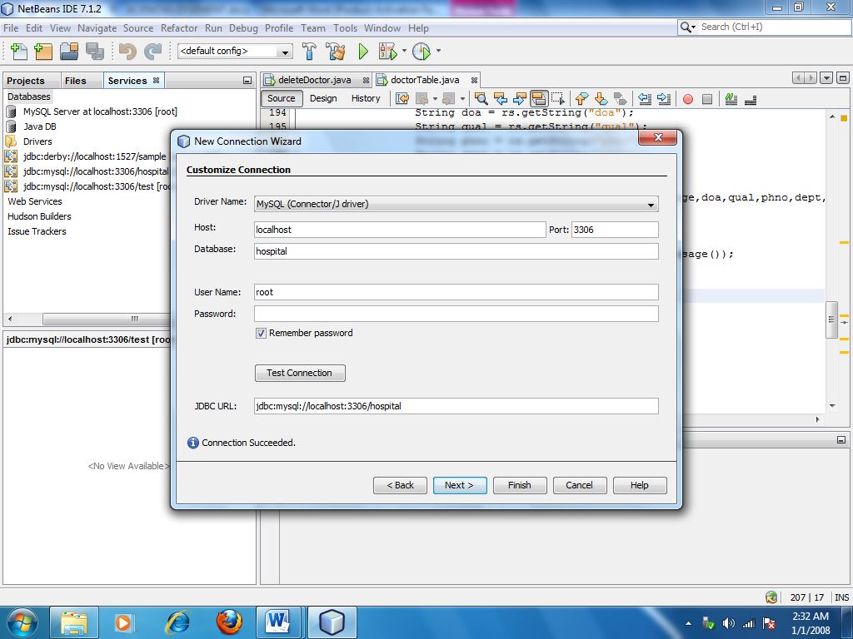

# Step 5:

Test the full application (Front end and Back end) with multiple sample sets of data are collected from potential user of the application randomly.

*SOFTWARE USED:*

1.NetBeans IDE 8.2

2.MySql

3.Windows 7 or more

*HARDWARE USED:*

1.Pc with i3 processor or more

**DATABASE:hospital**

Table:Patient

|  |  |  |  |
| --- | --- | --- | --- |
| FIELD NAME | DATATYPE | CONSTRAINT | REMARKS |
| P_id | Int | Primary key | ID of patient |
| P_name | Varchar |  | Name of patient |
| Date | Date |  | Date |
| Age | Int |  | Age of patient |
| F_name | Varchar |  | Father’s name of patient |
| Address | Varchar |  | Address of patient |
| PHno | Bigint |  | Phone number of patient |
| Aadhar | Bigint |  | Aadhar number of patient |
| Gender | Varchar |  | Gender of patient |
| Dept | Varchar |  | Department |

Table: Doctor

|  |  |  |  |
| --- | --- | --- | --- |
| FIELD NAME | DATATYPE | CONSTRAINT | REMARKS |
| D_id | Int | Primary key | ID of Doctor |
| D_name | Varchar |  | Name of Doctor |
| Doa | Date |  | Date of appointment |
| Age | Int |  | Age of Doctor |
| Qual | Varchar |  | Qualification of Doctor |
| PHno | Bigint |  | Phone number of patient |
| Gender | Varchar |  | Gender of patient |
| Dept | Varchar |  | Department |

**Project Details**

**1.Login Form**: It is the first frame where it asks for username and password. Then it checks this with a valid username and password.

**2.Account Form**: In this, user decide that whose data is to inserted -Patient or Doctor.

1. **Patient Form**: If the user choses patient form in account form, then this form gives 4 option:

* Insert form: It is the form where user can add new patient details.
* Delete form: It is the form where user can delete patient details.
* Update form: It is the form where user can update existing patient details.
* View all: It show details of all the patient.
* Generate Bill: It is used to generate bill of the patient.

1. **Doctor Form**: If the user choses Delete form in account form, then this form gives 5 option:

* Insert form: It is the form where user can add new Doctor details.
* Delete form: It is the form where user can delete Doctor details.
* Update form: It is the form where user can update existing Doctor details.
* View all: It show details of all the Doctor.

Login form

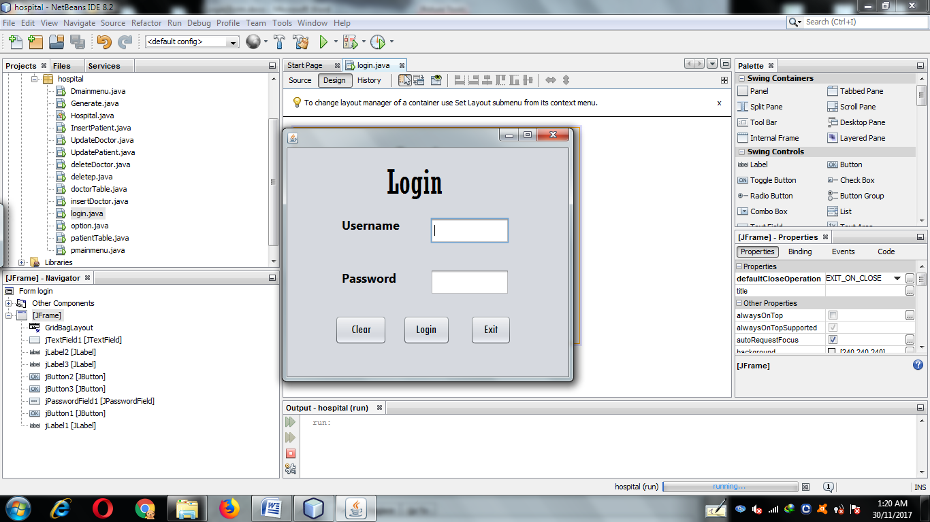

**1.Login button**

**private void jButton1ActionPerformed(java.awt.event.ActionEventevt) {**

String user=jTextField1.getText();

String pwd=new String(jPasswordField1.getPassword());

if (user.equals("admin") &&pwd.equals("admin")){

JOptionPane.showMessageDialog(this,"Access Granted");

new option().setVisible(true);

this.dispose();

}

else{

JOptionPane.showMessageDialog(this,"Access Not Granted");}

**}**

**2.Clear button**

**private void jButton2ActionPerformed(java.awt.event.ActionEventevt) {**

jTextField1.setText("");

jPasswordField1.setText("");

**}**

**3.Exit button**

**private void jButton3ActionPerformed(java.awt.event.ActionEventevt) {**

System.exit(0); **}**

account form

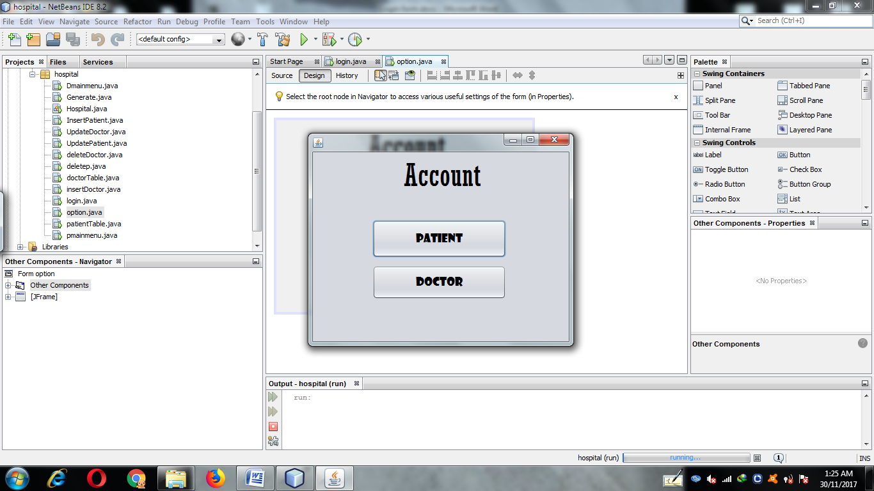

1.Patient button

**private void jButton1ActionPerformed(java.awt.event.ActionEventevt) {**

newpmainmenu().setVisible(true);

this.dispose();

**}**

**2.Doctor button**

**private void jButton2ActionPerformed(java.awt.event.ActionEventevt) {**

newDmainmenu().setVisible(true);

this.dispose();

}

Patient main menu

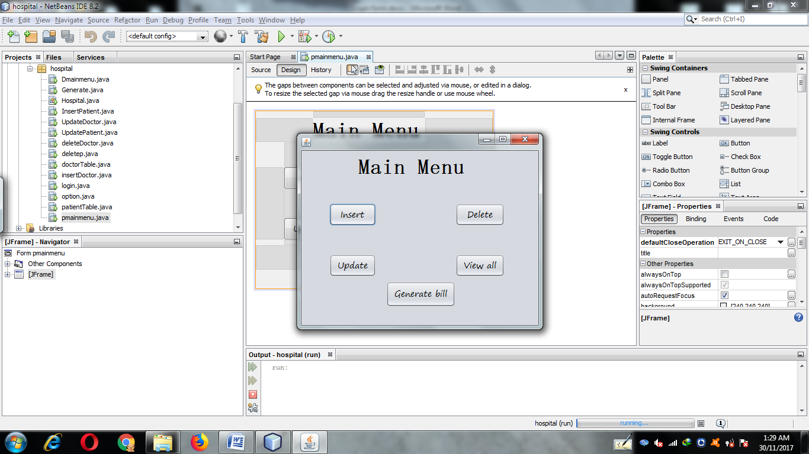

**1.Insert button**

**private void jButton1ActionPerformed(java.awt.event.ActionEventevt) {**

newInsertPatient().setVisible(true);

this.dispose();

**}**

**2.Delete button**

**private void jButton2ActionPerformed(java.awt.event.ActionEventevt) {**

newdeletep().setVisible(true);

this.dispose();

**}**

**3.Update button**

**private void jButton3ActionPerformed(java.awt.event.ActionEventevt) {**

newUpdatePatient().setVisible(true);

this.dispose();

**}**

**4.Patient Table button**

**private void jButton4ActionPerformed(java.awt.event.ActionEventevt) {**

newpatientTable().setVisible(true);

this.dispose();

**}**

**5.Generate button**

**private void jButton5ActionPerformed(java.awt.event.ActionEventevt) {**

new Generate().setVisible(true);

this.dispose();

**}**

insert Patient Records

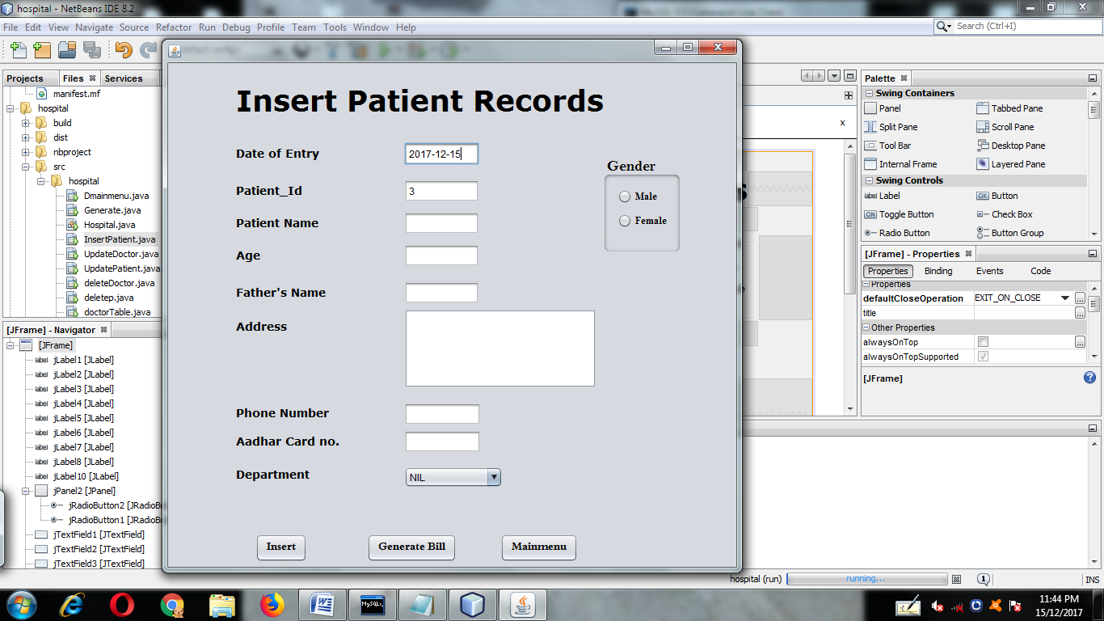

**private void formWindowActivated(java.awt.event.WindowEventevt) {**

try

{

Class.forName("com.mysql.jdbc.Driver");

Connection con=DriverManager.getConnection("jdbc:mysql://localhost:3306/hospital","root","");

Statement stmt=con.createStatement();

String query="select P_ID from patient;";

ResultSetrs=stmt.executeQuery(query);

int z,i=0;

while(rs.next())

{

i=rs.getInt("P_id");

z=i+1;

jTextField2.setText(""+z);

}

if(jTextField2.getText().equals(""))

{

jTextField2.setText(""+1);

}

String query1="select curdate();";

ResultSet rs1=stmt.executeQuery(query1);

while(rs1.next())

{

String date=rs1.getString("curdate()");

jTextField1.setText(date);

}

}

catch(Exception e)

{

JOptionPane.showMessageDialog(this,e.getMessage());

}

jTextField2.setEditable(false);

**}**

**1.Insert button**

**private void jButton1ActionPerformed(java.awt.event.ActionEventevt) {**

try{

Class.forName("com.mysql.jdbc.Driver");

Connection con=DriverManager.getConnection("jdbc:mysql://localhost:3306/hospital","root","");

Statement stmt=con.createStatement();

String query="select curdate();";

ResultSetrs=stmt.executeQuery(query);

while(rs.next())

{

jTextField1.setText(rs.getString("curdate()"));

}

String P_ID=jTextField2.getText();

String PNAME=jTextFiel3.getText();

String age=jTextField4.getText();

String Fname=jTextField5.getText();

String date=jTextField1.getText();

String address=jTextArea1.getText();

String Phno=jTextField6.getText();

String aadhar=jTextField7.getText();

String dept=(String)jComboBox1.getSelectedItem();

String gender;

if(jRadioButton1.isSelected()){

gender="Male";

}

else {

gender="Female";

}

String query2="insert into patient values("+"'"+date+"','"+

P_ID+"','"+

PNAME+"','"+

age+"','"+

Fname+"','"+

address+"','"+

Phno+"','"+

aadhar+"','"+

gender+"','"+

dept+"');";

JOptionPane.showMessageDialog(this,query2);

stmt.executeUpdate(query2);

}

catch(Exception e)

{

JOptionPane.showMessageDialog(this,e.getMessage());

}

int a=JOptionPane.showConfirmDialog(this,"record inserted!! go to main menu ");

if (a==JOptionPane.YES_OPTION)

{

newpmainmenu().setVisible(true);

this.dispose();

}

else

{

JOptionPane.showMessageDialog(this,"you can add more data");

}

**}**

**2.Generate button**

**private void jButton2ActionPerformed(java.awt.event.ActionEventevt) {**

new Generate().setVisible(true);

this.dispose();

**}**

**3.Main Menu button**

**private void jButton3ActionPerformed(java.awt.event.ActionEventevt) {**

newpmainmenu().setVisible(true);

this.dispose();

**}**

Update Patient Records

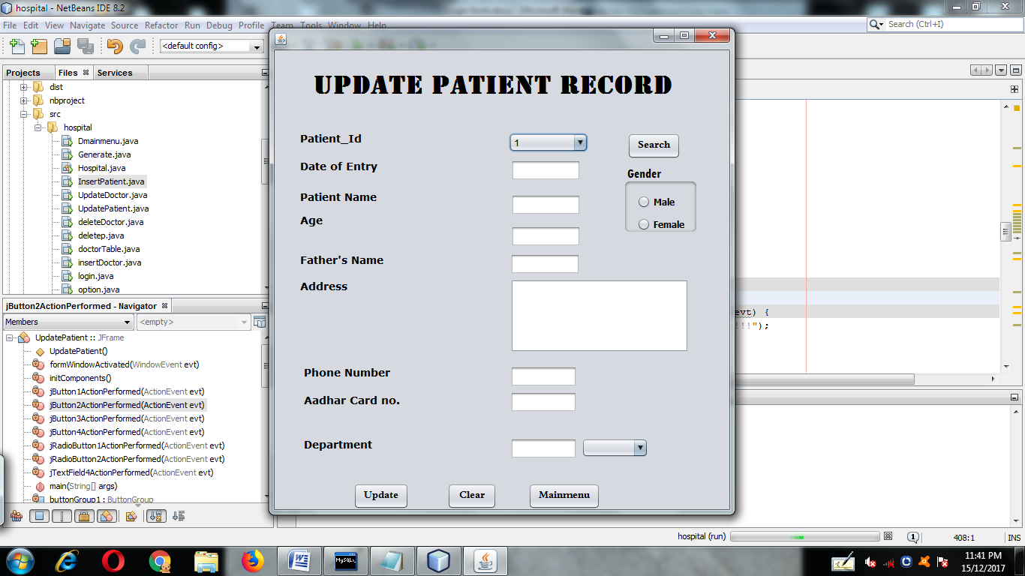

**private void formWindowActivated(java.awt.event.WindowEventevt) {**

try

{Class.forName("com.mysql.jdbc.Driver");

Connection con=DriverManager.getConnection("jdbc:mysql://localhost:3306/hospital","root","");

Statement stmt=con.createStatement();

String query="select P_ID from patient;";

ResultSetrs=stmt.executeQuery(query);

while(rs.next())

{

jComboBox1.addItem(rs.getString("P_ID"));

}

}

catch(Exception e)

{

JOptionPane.showMessageDialog(this,e.getMessage());

}

**}**

**1.Search button**

**private void jButton1ActionPerformed(java.awt.event.ActionEventevt) {**

try

{Class.forName("com.mysql.jdbc.Driver");

Connection con=DriverManager.getConnection("jdbc:mysql://localhost:3306/hospital","root","");

Statement stmt=con.createStatement();

String pid=(String)jComboBox1.getSelectedItem();

String query="select * from patient where P_ID='"+pid+"';";

ResultSetrs=stmt.executeQuery(query);

while(rs.next())

{

jTextField2.setText(rs.getString("P_Name"));

jTextField1.setText(rs.getString("date"));

jTextField3.setText(rs.getString("age"));

jTextField4.setText(rs.getString("F_name"));

jTextArea1.setText(rs.getString("address"));

jTextField5.setText(rs.getString("phno"));

jTextField6.setText(rs.getString("aadhar"));

jTextField7.setText(rs.getString("dept"));

String g=rs.getString("gender");

if(g.equals("Male"))

{jRadioButton1.setSelected(true); }

if(g.equals("Female"))

{

jRadioButton2.setSelected(true);

}

}}

catch(Exception e)

{

JOptionPane.showMessageDialog(this,e.getMessage());

}

String d=jTextField7.getText();

if(d.equals("ortho"))

{jComboBox2.addItem("Ortho");

jComboBox2.addItem("Psychological");

jComboBox2.addItem("Surgical");

jComboBox2.addItem("Neurological");

}

else if(d.equals("Surgical"))

{jComboBox2.addItem("Surgical");

jComboBox2.addItem("Ortho");

jComboBox2.addItem("Psychological");

jComboBox2.addItem("Neurological");

}

else if(d.equals("Neurological"))

{ jComboBox2.addItem("Neurological");

jComboBox2.addItem("Ortho");

jComboBox2.addItem("Psychological");

jComboBox2.addItem("Surgical");

}

else if(d.equals("Psychological"))

{jComboBox2.addItem("Psychological");

jComboBox2.addItem("Ortho");

jComboBox2.addItem("Surgical");

jComboBox2.addItem("Neurological");

}**}**

**2.Update button**

**private void jButton2ActionPerformed(java.awt.event.ActionEventevt) {**

int a=JOptionPane.showConfirmDialog(null,"want to update a record...!!!");

if(a==JOptionPane.YES_OPTION)

{try

{

Class.forName("com.mysql.jdbc.Driver");

Connection con=DriverManager.getConnection("jdbc:mysql://localhost:3306/hospital","root","");

Statement stmt=con.createStatement();

String query="update patient set "+

"Date='"+jTextField1.getText()+"',"+

"P_Name='"+jTextField2.getText()+"',"+

"age='"+jTextField3.getText()+"',"+

"F_Name='"+jTextField4.getText()+"',"+

"address='"+jTextArea1.getText()+"',"+

"phno='"+jTextField5.getText()+"',"+

"dept='"+jComboBox2.getSelectedItem()+"',"+

"aadhar='"+jTextField6.getText()+"';";

stmt.executeUpdate(query);

JOptionPane.showMessageDialog(this,"recorded");

}

catch(Exception e)

{

JOptionPane.showMessageDialog(this,e.getMessage());

}}

**}**

**3.Clear button**

**private void jButton3ActionPerformed(java.awt.event.ActionEventevt) {**

jTextField1.setText("");

jTextField2.setText("");

jTextField3.setText("");

jTextField4.setText("");

jTextField5.setText("");

jTextField6.setText("");

jTextField7.setText("");

jTextArea1.setText("");

jRadioButton1.setSelected(false);

jRadioButton2.setSelected(false);

jComboBox2.removeAllItems();

**}**

**4.Main Menu button**

**private void jButton4ActionPerformed(java.awt.event.ActionEvent evt) {**

new pmainmenu().setVisible(true);

this.dispose();

**}**

delete Patient Records

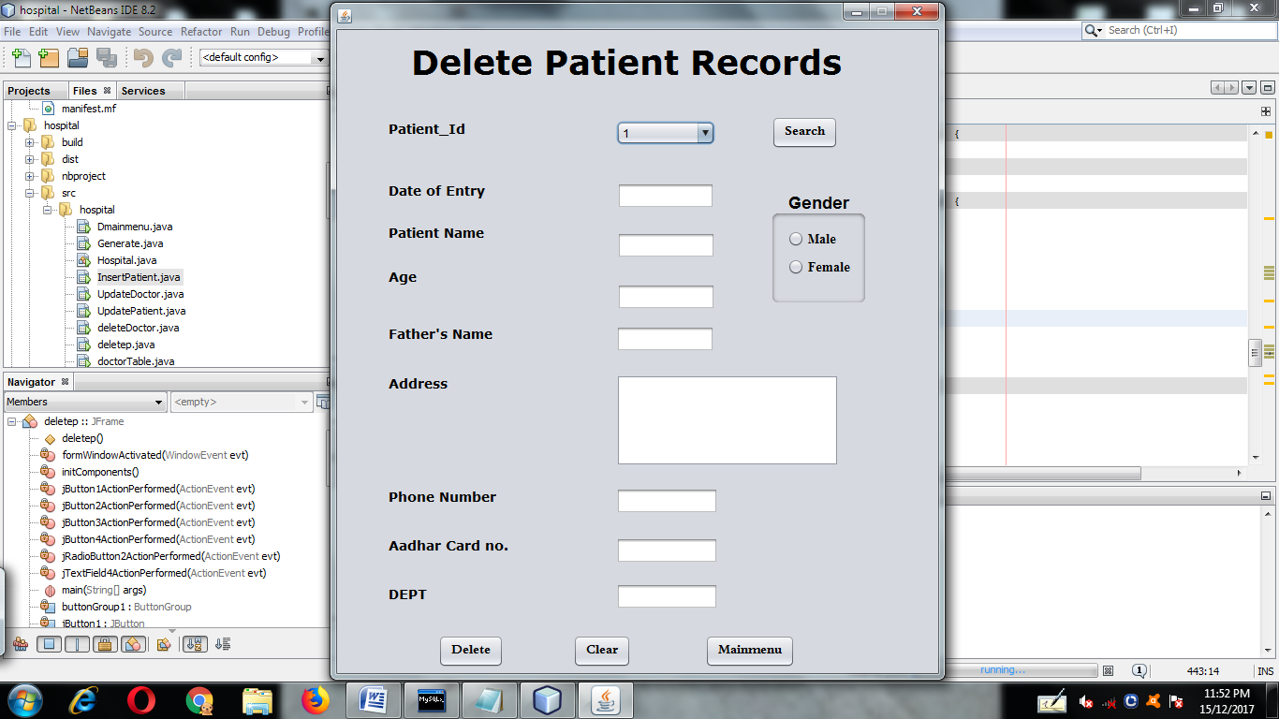

**private void formWindowActivated(java.awt.event.WindowEventevt) {**

try

{

Class.forName("com.mysql.jdbc.Driver");

Connection con=DriverManager.getConnection("jdbc:mysql://localhost:3306/hospital","root","");

Statement stmt=con.createStatement();

String query="select P_ID from patient;";

ResultSetrs=stmt.executeQuery(query);

while(rs.next())

{

jComboBox1.addItem(rs.getString("P_ID"));

}

}

catch(Exception e)

{

JOptionPane.showMessageDialog(this,e.getMessage());

}

jTextField1.setEditable(false);

jTextField2.setEditable(false);

jTextField3.setEditable(false);

jTextField4.setEditable(false);

jTextField5.setEditable(false);

jTextField6.setEditable(false);

jTextField7.setEditable(false);

jTextArea1.setEditable(false);

**}**

**1.Search button**

**private void jButton1ActionPerformed(java.awt.event.ActionEventevt) {**

try

{

Class.forName("com.mysql.jdbc.Driver");

Connection con=DriverManager.getConnection("jdbc:mysql://localhost:3306/hospital","root","");

Statement stmt=con.createStatement();

String pid=(String)jComboBox1.getSelectedItem();

String query="select * from patient where P_ID='"+pid+"';";

ResultSetrs=stmt.executeQuery(query);

while(rs.next())

{

jTextField2.setText(rs.getString("P_Name"));

jTextField1.setText(rs.getString("date"));

jTextField3.setText(rs.getString("age"));

jTextField4.setText(rs.getString("F_name"));

jTextArea1.setText(rs.getString("address"));

jTextField5.setText(rs.getString("phno"));

jTextField6.setText(rs.getString("aadhar"));

jTextField7.setText(rs.getString("dept"));

String g=rs.getString("gender");

if(g.equals("Male"))

jRadioButton1.setSelected(true);

if(g.equals("Female"))

jRadioButton2.setSelected(true);

}

}

catch(Exception e)

{

JOptionPane.showMessageDialog(this,e.getMessage());

}

**}**

**2.Delete button**

**private void jButton2ActionPerformed(java.awt.event.ActionEventevt) {**

int a=JOptionPane.showConfirmDialog(null,"want to delete a record...!!!");

if(a==JOptionPane.YES_OPTION)

{

try

{

Class.forName("com.mysql.jdbc.Driver");

Connection con=DriverManager.getConnection("jdbc:mysql://localhost:3306/hospital","root","");

Statement stmt=con.createStatement();

String query="delete from patient where P_ID="+jComboBox1.getSelectedItem()+";";

stmt.executeUpdate(query);

JOptionPane.showMessageDialog(this,"deleted");

}

catch(Exception e){

JOptionPane.showMessageDialog(this,e.getMessage());

}

}

**}**

**3.Main Menu button**

**private void jButton3ActionPerformed(java.awt.event.ActionEventevt) {**

newpmainmenu().setVisible(true);

this.dispose();

**}**

**4.Clear button**

**private void jButton4ActionPerformed(java.awt.event.ActionEvent evt) {**

jTextField1.setText("");

jTextField2.setText("");

jTextField3.setText("");

jTextField4.setText("");

jTextField5.setText("");

jTextField6.setText("");

jTextField7.setText("");

jTextArea1.setText("");

jRadioButton1.setSelected(false);

jRadioButton2.setSelected(false);

**}**

Patient Table

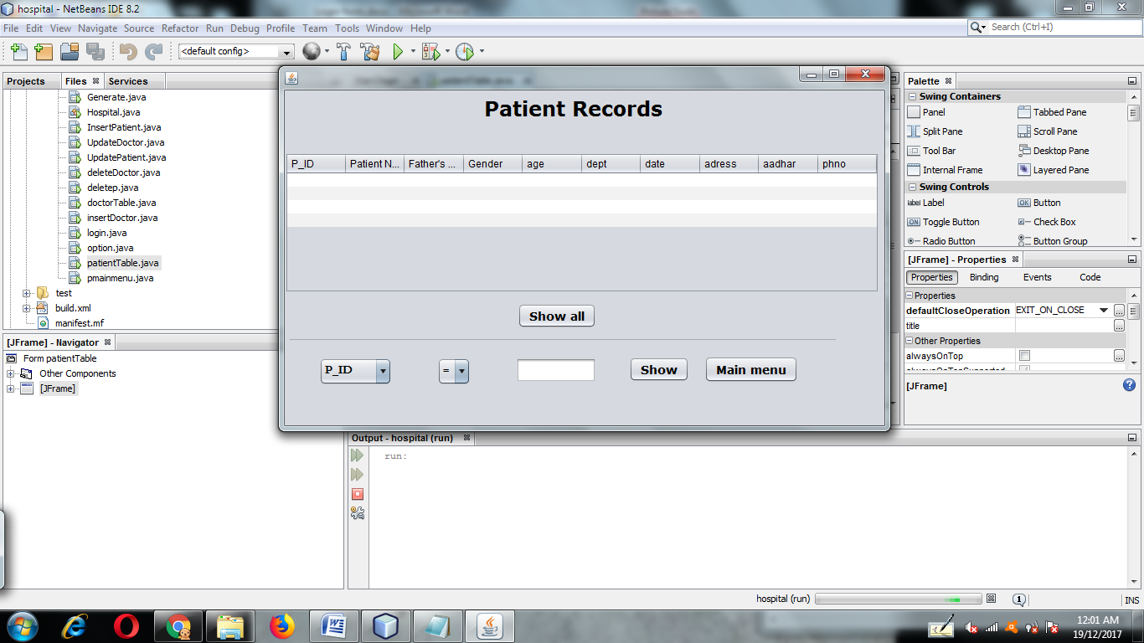

**1.Show All button**

**private void jButton1ActionPerformed(java.awt.event.ActionEventevt) {**

DefaultTableModel model=(DefaultTableModel)jTable1.getModel();

int rows=model.getRowCount();

if(rows>0)

{

for (int i=0;i<rows;i++)

{

model.removeRow(0);

}

}

try

{

Class.forName("com.mysql.jdbc.Driver");

Connection con=DriverManager.getConnection("jdbc:mysql://localhost:3306/hospital","root","");

Statement stmt=con.createStatement();

String q="select * from patient";

ResultSetrs=stmt.executeQuery(q);

while(rs.next())

{

String P_Id=rs.getString("P_ID");

String PName=rs.getString("P_Name");

String Fname=rs.getString("F_Name");

String gender=rs.getString("gender");

String age=rs.getString("age");

String dept=rs.getString("dept");

String date=rs.getString("date");

String address=rs.getString("address");

String ph=rs.getString("phno");

String aadhar=rs.getString("aadhar");

model.addRow(new Object[]{P_Id,PName,Fname,gender,age,dept,date,address,ph,aadhar});

}

}

catch(Exception e)

{

JOptionPane.showMessageDialog(this,e.getMessage());

}

**}**

**2.Show button**

**private void jButton2ActionPerformed(java.awt.event.ActionEventevt) {**

DefaultTableModel model=(DefaultTableModel)jTable1.getModel();

int rows=model.getRowCount();

if(rows>0)

{

for (int i=0;i<rows;i++)

{

model.removeRow(0);

}

}

try

{

Class.forName("com.mysql.jdbc.Driver");

Connection con=DriverManager.getConnection("jdbc:mysql://localhost:3306/hospital","root","");

Statement stmt=con.createStatement();

String f=(String)jComboBox1.getSelectedItem();

String o=(String)jComboBox2.getSelectedItem();

String c=(String)jTextField1.getText();

String q="select * from patient where "+f+o+"'"+c+"'";

JOptionPane.showMessageDialog(this,q);

ResultSetrs=stmt.executeQuery(q);

while(rs.next())

{

String P_Id=rs.getString("P_ID");

String PName=rs.getString("P_Name");

String Fname=rs.getString("F_Name");

String gender=rs.getString("gender");

String age=rs.getString("age");

String dept=rs.getString("dept");

String date=rs.getString("date");

String address=rs.getString("address");

String ph=rs.getString("phno");

String aadhar=rs.getString("aadhar");

model.addRow(new Object[]{P_Id,PName,Fname,gender,age,dept,date,address,ph,aadhar});

}

}

catch(Exception e)

{

JOptionPane.showMessageDialog(this,e.getMessage());

}

**}**

**3.Main Menu button**

**private void jButton3ActionPerformed(java.awt.event.ActionEvent evt) {**

new pmainmenu().setVisible(true);

this.dispose();

**}**

Generate Bill form

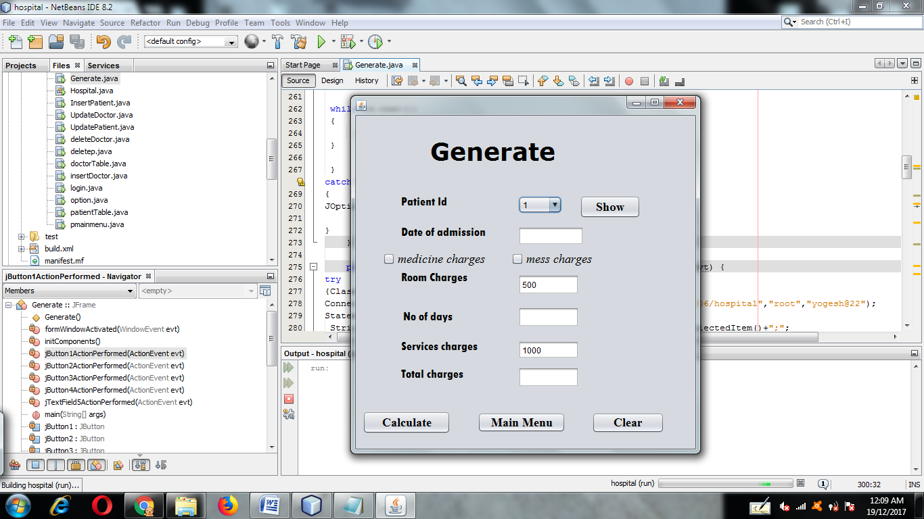

**private void formWindowActivated(java.awt.event.WindowEvent evt) {**

jTextField1.setText("500");

jTextField3.setText("1000");

try

{

Class.forName("com.mysql.jdbc.Driver");

Connection con=DriverManager.getConnection("jdbc:mysql://localhost:3306/hospital","root","");

Statement stmt=con.createStatement();

String query="select P_ID from patient;";

ResultSet rs=stmt.executeQuery(query);

while(rs.next())

{

jComboBox1.addItem(rs.getString("P_ID"));

}

}

catch(Exception e)

{

JOptionPane.showMessageDialog(this,e.getMessage());

}

**}**

**1.Show button**

**private void jButton1ActionPerformed(java.awt.event.ActionEvent evt) {**

try

{Class.forName("com.mysql.jdbc.Driver");

Connection con=DriverManager.getConnection("jdbc:mysql://localhost:3306/hospital","root","");

Statement stmt=con.createStatement();

String query="select date from patient where p_id="+jComboBox1.getSelectedItem()+";";

ResultSet rs=stmt.executeQuery(query);

while(rs.next())

{

jTextField5.setText(rs.getString("date"));

}

{

String query2="select datediff(curdate(),'"+jTextField5.getText()+"');";

ResultSet rs1=stmt.executeQuery(query2);

JOptionPane.showMessageDialog(this,query2);

while(rs1.next())

{

jTextField2.setText(rs1.getString("datediff(curdate(),'"+jTextField5.getText()+"')"));

}

}

}

catch(Exception e)

{

JOptionPane.showMessageDialog(this,e.getMessage());

}

**}**

**2.Calculate button**

**private void jButton2ActionPerformed(java.awt.event.ActionEvent evt) {**

int rc=500;

int nd=Integer.parseInt(jTextField2.getText());

int sc=Integer.parseInt(jTextField3.getText());

int t=0,mc=0,mess=0;

if(jCheckBox1.isSelected())

{

mc=10000;

}

if(jCheckBox2.isSelected())

{

mess=1000;

}

t=(rc*nd)+sc+mc+mess;

jTextField4.setText(""+t);

**}**

**3.Main Menu button**

**private void jButton3ActionPerformed(java.awt.event.ActionEvent evt) {**

new pmainmenu().setVisible(true);

this.dispose();

**}**

**4.Clear button**

**private void jButton4ActionPerformed(java.awt.event.ActionEvent evt) {**

jTextField1.setText("");

jTextField2.setText("");

jTextField3.setText("");

jTextField4.setText("");

jTextField5.setText("");

**}**

Doctor Main menu

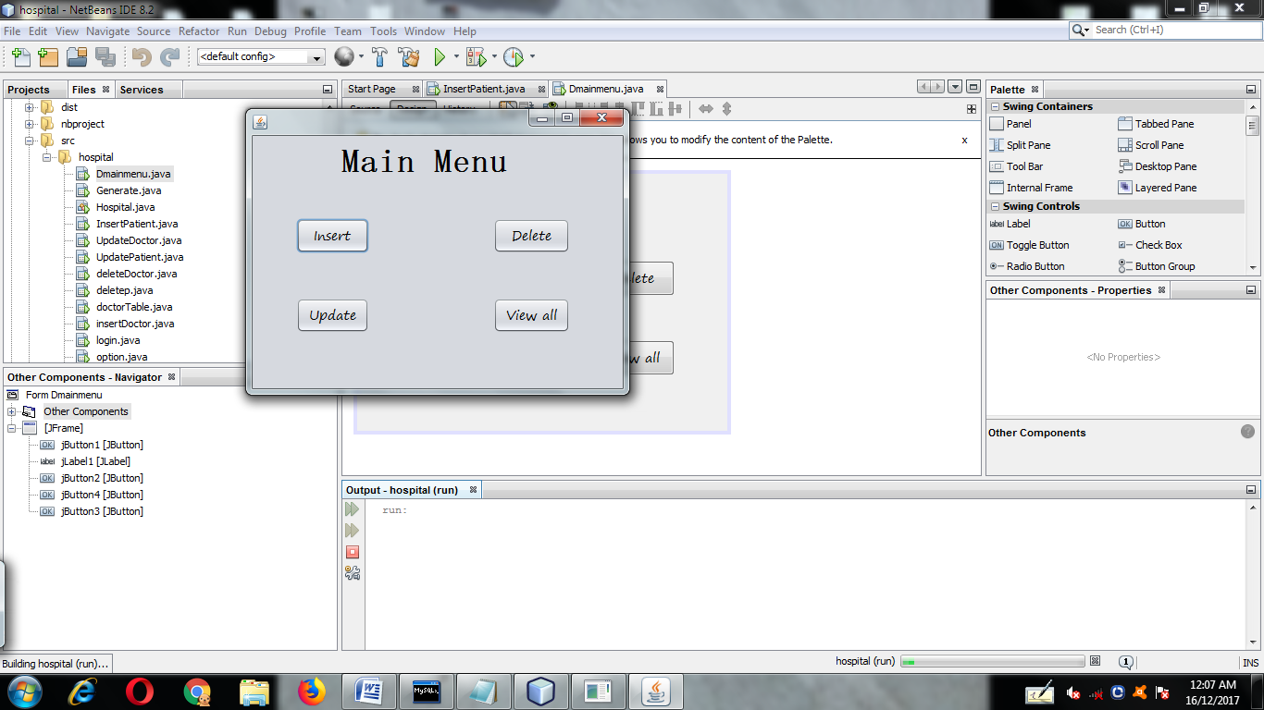

**1.Insert button**

**private void jButton1ActionPerformed(java.awt.event.ActionEventevt) {**

newinsertDoctor().setVisible(true);

this.dispose();

**}**

**2.Delete button**

**private void jButton2ActionPerformed(java.awt.event.ActionEventevt) {**

newdeleteDoctor().setVisible(true);

this.dispose();

**}**

**3.Update button**

**private void jButton3ActionPerformed(java.awt.event.ActionEventevt) {**

newUpdateDoctor().setVisible(true);

this.dispose();

**}**

**4.View All button**

**private void jButton4ActionPerformed(java.awt.event.ActionEventevt) {**

newdoctorTable().setVisible(true);

this.dispose();

**}**

insert Doctor Records

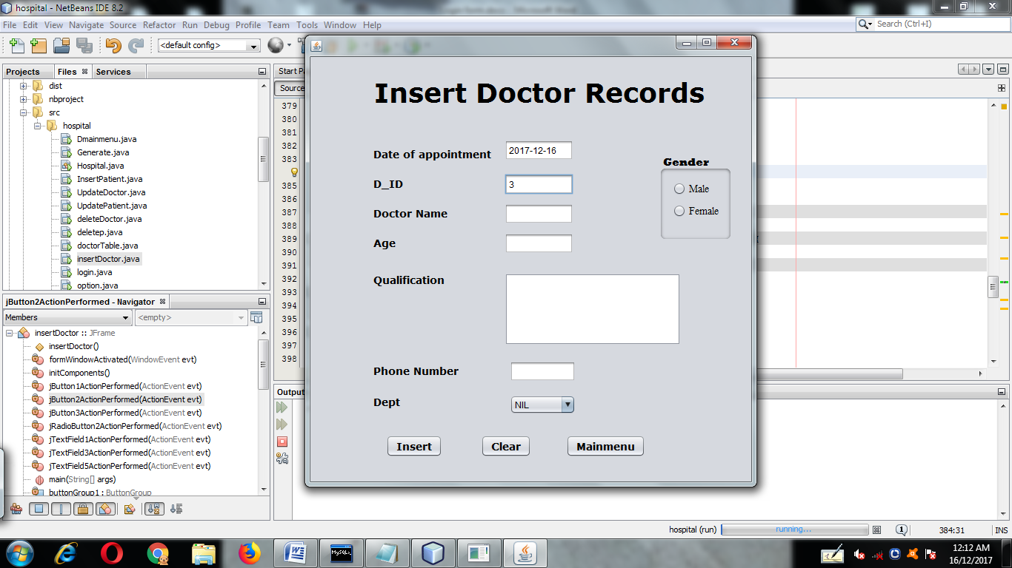

**private void formWindowActivated(java.awt.event.WindowEventevt) {**

try

{

Class.forName("com.mysql.jdbc.Driver");

Connection con=DriverManager.getConnection("jdbc:mysql://localhost:3306/hospital","root","");

Statement stmt=con.createStatement();

String query="select D_ID from doctor;";

ResultSetrs=stmt.executeQuery(query);

int z,i=0;

while(rs.next())

{

i=rs.getInt("d_id");

z=i+1;

jTextField2.setText(""+z);

}

if(jTextField2.getText().equals(""))

{ jTextField2.setText(""+1);}

String query1="select curdate();";

ResultSet rs1=stmt.executeQuery(query1);

while(rs1.next())

{

String date=rs1.getString("curdate()");

jTextField1.setText(date);

}

}

catch(Exception e)

{

JOptionPane.showMessageDialog(this,e.getMessage());

}

jTextField2.setEditable(false);

**}**

**1.Insert button**

**private void jButton1ActionPerformed(java.awt.event.ActionEventevt) {**

try {

Class.forName("com.mysql.jdbc.Driver");

Connection con = DriverManager.getConnection("jdbc:mysql://localhost:3306/hospital", "root", "");

Statement stmt = con.createStatement();

String query = "select curdate();";

ResultSetrs = stmt.executeQuery(query);

while (rs.next()) {

jTextField1.setText(rs.getString("curdate()"));

}

String D_ID = jTextField2.getText();

String DNAME = jTextField3.getText();

String age = jTextField4.getText();

String doa = jTextField1.getText();

String qual = jTextArea1.getText();

String Phno = jTextField5.getText();

String dept = (String) jComboBox1.getSelectedItem();

String gender;

if (jRadioButton1.isSelected())

{

gender = "Male";

}

else

{

gender = "Female";

}

String query2 = "insert into doctor values('"+D_ID+ "','"

+DNAME + "','"

+ age + "','"

+ doa + "','"

+ qual + "','"

+ Phno + "','"

+ dept + "','"

+ gender + "');";

JOptionPane.showMessageDialog(this, query2);

stmt.executeUpdate(query2);

}

catch (Exception e)

{

JOptionPane.showMessageDialog(this, e.getMessage());

}

int a = JOptionPane.showConfirmDialog(this, "record inserted!! go to main menu ");

if (a == JOptionPane.YES_OPTION) {

newDmainmenu().setVisible(true);

this.dispose();

} else {

JOptionPane.showMessageDialog(this, "you can add more data");

}

**}**

**2.Clear button**

**private void jButton2ActionPerformed(java.awt.event.ActionEventevt) {**

jTextField1.setText("");

jTextField2.setText("");

jTextField3.setText("");

jTextField4.setText("");

jTextField5.setText("");

jTextArea1.setText("");

jComboBox1.setSelectedIndex(0);

jRadioButton1.setSelected(false);

jRadioButton2.setSelected(false);

**}**

**3.Main Menu button**

**private void jButton3ActionPerformed(java.awt.event.ActionEventevt) {**

newDmainmenu().setVisible(true);

this.dispose();

**}**

update Doctor Records

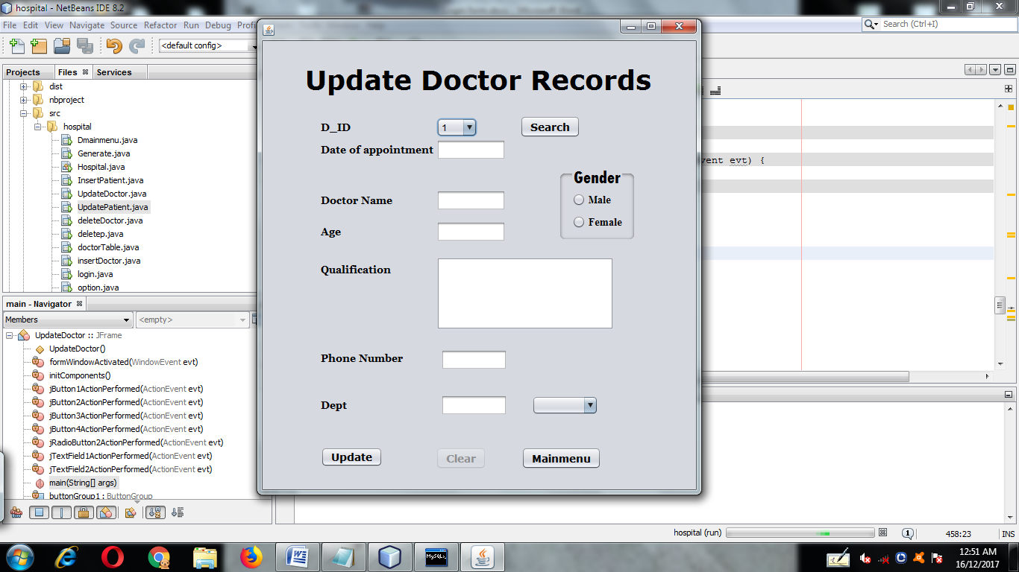

**private void formWindowActivated(java.awt.event.WindowEventevt) {**

try{

Class.forName("com.mysql.jdbc.Driver");

Connection con=DriverManager.getConnection("jdbc:mysql://localhost:3306/hospital","root","");

Statement stmt=con.createStatement();

String query="select D_ID from doctor;";

ResultSetrs=stmt.executeQuery(query);

while(rs.next()){

jComboBox1.addItem(rs.getString("D_ID"));

}

}

catch(Exception e){

JOptionPane.showMessageDialog(this,e.getMessage());

}

jButton3.setEnabled(false);

**}**

**1.Search button**

**private void jButton1ActionPerformed(java.awt.event.ActionEventevt) {**

try

{

Class.forName("com.mysql.jdbc.Driver");

Connection con=DriverManager.getConnection("jdbc:mysql://localhost:3306/hospital","root","");

Statement stmt=con.createStatement();

String did=(String)jComboBox1.getSelectedItem();

String query="select * from doctor where D_ID='"+did+"';";

ResultSetrs=stmt.executeQuery(query);

while(rs.next()){

jTextField1.setText(rs.getString("doa"));

jTextField2.setText(rs.getString("D_Name"));

jTextField3.setText(rs.getString("age"));

jTextField4.setText(rs.getString("phno"));

jTextArea1.setText(rs.getString("qual"));

jTextField5.setText(rs.getString("dept"));

String g=rs.getString("gender");

if(g.equals("Male")){

jRadioButton1.setSelected(true);

}

if(g.equals("Female")){

jRadioButton2.setSelected(true);

}

}

}

catch(Exception e){

JOptionPane.showMessageDialog(this,e.getMessage());

}

jButton1.setEnabled(false);

jButton3.setEnabled(true);

**}**

**2.Update button**

**private void jButton2ActionPerformed(java.awt.event.ActionEventevt) {**

try {

Class.forName("com.mysql.jdbc.Driver");

Connection con = DriverManager.getConnection("jdbc:mysql://localhost:3306/hospital", "root", "");

Statement stmt = con.createStatement();

String D_ID = (String)jComboBox1.getSelectedItem();

String DNAME = jTextField2.getText();

String age = jTextField3.getText();

String doa = jTextField1.getText();

String qual = jTextArea1.getText();

String Phno = jTextField4.getText();

String dept = (String) jComboBox1.getSelectedItem();

String gender;

if (jRadioButton1.isSelected())

{

gender = "Male";

}

else {

gender = "Female";

}

String query2 = "insert into doctor values('"+D_ID+ "','"

+DNAME + "','"

+ age + "','"

+ doa + "','"

+ qual + "','"

+ Phno + "','"

+ dept + "','"

+ gender + "');";

JOptionPane.showMessageDialog(this, query2);

stmt.executeUpdate(query2);

}

catch (Exception e)

{

JOptionPane.showMessageDialog(this, e.getMessage());

}

int a = JOptionPane.showConfirmDialog(this, "record inserted!! go to main menu ");

if (a == JOptionPane.YES_OPTION) {

newpmainmenu().setVisible(true);

this.dispose();

}

else

{

JOptionPane.showMessageDialog(this, "you can add more data");

}

**}**

**3.Clear button**

**private void jButton3ActionPerformed(java.awt.event.ActionEventevt) {**

jTextField1.setText("");

jTextField2.setText("");

jTextField3.setText("");

jTextField4.setText("");

jTextField5.setText("");

jTextArea1.setText("");

jRadioButton1.setSelected(false);

jRadioButton2.setSelected(false);

jButton1.setEnabled(true);

jButton3.setEnabled(false);

jComboBox2.removeAllItems();

**}**

**4.Main Menu button**

**private void jButton4ActionPerformed(java.awt.event.ActionEventevt) {**

newDmainmenu().setVisible(true);

this.dispose();

**}**

Delete Doctor Records

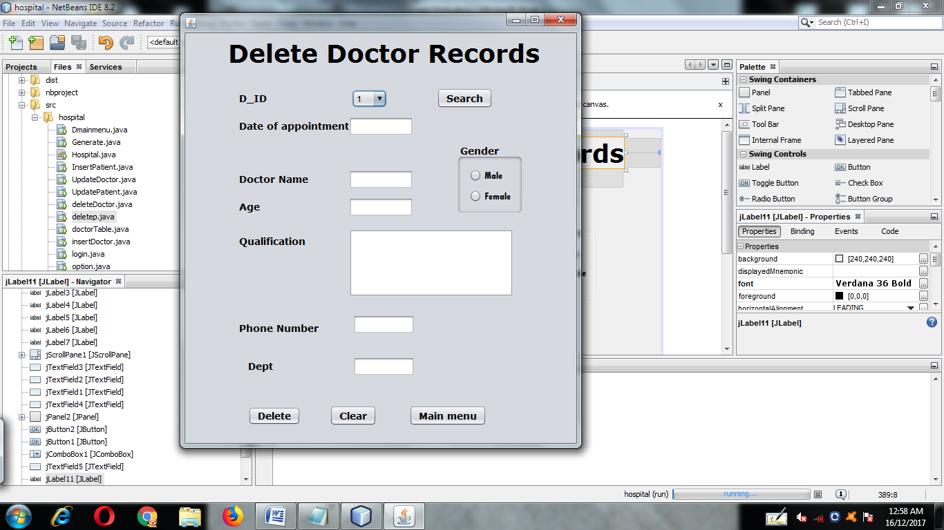

**private void formWindowActivated(java.awt.event.WindowEventevt) {**

try

{Class.forName("com.mysql.jdbc.Driver");

Connection con=DriverManager.getConnection("jdbc:mysql://localhost:3306/hospital","root","");

Statement stmt=con.createStatement();

String query="select D_ID from doctor;";

ResultSetrs=stmt.executeQuery(query);

while(rs.next())

{

jComboBox1.addItem(rs.getString("D_ID"));

}

}

catch(Exception e)

{

JOptionPane.showMessageDialog(this,e.getMessage());

}

jTextField1.setEditable(false);

jTextField2.setEditable(false);

jTextField3.setEditable(false);

jTextField4.setEditable(false);

jTextField5.setEditable(false);

jTextArea1.setEditable(false);

**}**

**1.Search button**

**private void jButton1ActionPerformed(java.awt.event.ActionEventevt) {**

try

{

Class.forName("com.mysql.jdbc.Driver");

Connection con=DriverManager.getConnection("jdbc:mysql://localhost:3306/hospital","root","");

Statement stmt=con.createStatement();

String did=(String)jComboBox1.getSelectedItem();

String query="select * from doctor where D_ID='"+did+"';";

ResultSetrs=stmt.executeQuery(query);

while(rs.next())

{

jTextField1.setText(rs.getString("doa"));

jTextField2.setText(rs.getString("D_Name"));

jTextField3.setText(rs.getString("age"));

jTextField4.setText(rs.getString("phno"));

jTextArea1.setText(rs.getString("qual"));

jTextField5.setText(rs.getString("dept"));

String g=rs.getString("gender");

if(g.equals("Male"))

{

jRadioButton1.setSelected(true);

}

if(g.equals("Female"))

{

jRadioButton2.setSelected(true);

}

}

}

catch(Exception e)

{

JOptionPane.showMessageDialog(this,e.getMessage());

}

**}**

**2.Delete button**

**private void jButton2ActionPerformed(java.awt.event.ActionEventevt) {**

try {

Class.forName("com.mysql.jdbc.Driver");

Connection con = DriverManager.getConnection("jdbc:mysql://localhost:3306/hospital", "root", "");

Statement stmt = con.createStatement();

String did=(String)jComboBox1.getSelectedItem();

String query = "delete from doctor where d_id='"+did+"';";

JOptionPane.showMessageDialog(this, query);

stmt.executeUpdate(query);

}

catch (Exception e)

{

JOptionPane.showMessageDialog(this, e.getMessage());

}

int a = JOptionPane.showConfirmDialog(this, "record deleted!! go to main menu ");

if (a == JOptionPane.YES_OPTION) {

newpmainmenu().setVisible(true);

this.dispose();

}

**}**

**3.Clear button**

**private void jButton3ActionPerformed(java.awt.event.ActionEventevt) {**

jTextField1.setText("");

jTextField2.setText("");

jTextField3.setText("");

jTextField4.setText("");

jTextField5.setText("");

jTextArea1.setText("");

jComboBox1.setSelectedIndex(1);

jRadioButton1.setSelected(false);

jRadioButton2.setSelected(false);

**}**

Doctor Table

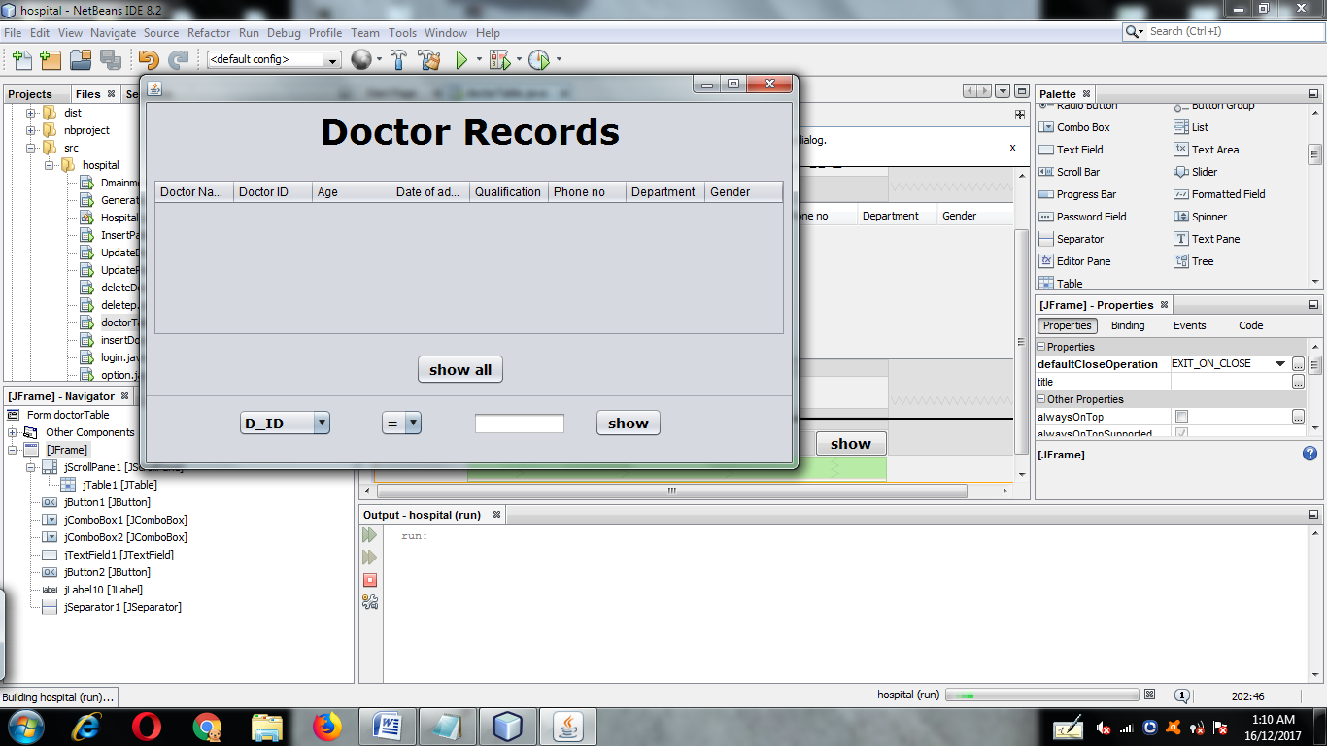

**1.Show All button**

**private void jButton1ActionPerformed(java.awt.event.ActionEventevt) {**

DefaultTableModel model = (DefaultTableModel) jTable1.getModel();

int rows=model.getRowCount();

if (rows > 0) {

for(int i=0;i<rows;i++) {

model.removeRow(0);

}

}

try

{

Class.forName("com.mysql.jdbc.Driver");

Connection con = DriverManager.getConnection("jdbc:mysql://localhost:3306/hospital", "root", "");

Statement stmt = con.createStatement();

String q = "select * from doctor;";

ResultSetrs=stmt.executeQuery(q);

while (rs.next()) {

String D_Id = rs.getString("D_ID");

String D_Name = rs.getString("D_Name");

String age = rs.getString("age");

String doa = rs.getString("doa");

String qual = rs.getString("qual");

String phno = rs.getString("phno");

String dept = rs.getString("dept");

String gender = rs.getString("gender");

model.addRow(new Object[]{D_Id, D_Name,age,doa,qual,phno,dept,gender});

}

}

catch (Exception e)

{

JOptionPane.showMessageDialog(this, e.getMessage());

}

**}**

**2.Show button**

**private void jButton2ActionPerformed(java.awt.event.ActionEventevt) {**

DefaultTableModel model = (DefaultTableModel) jTable1.getModel();

int rows = model.getRowCount();

if (rows > 0)

{

for (int i = 0; i < rows; i++)

{

model.removeRow(0);

}

}

try

{

Class.forName("com.mysql.jdbc.Driver");

Connection con = DriverManager.getConnection("jdbc:mysql://localhost:3306/hospital", "root", "");

Statement stmt = con.createStatement();

String f = (String) jComboBox1.getSelectedItem();

String o = (String) jComboBox2.getSelectedItem();

String c = (String) jTextField1.getText();

String q = "select * from doctor where " + f + o + "'" + c + "';";

JOptionPane.showMessageDialog(this, q);

ResultSetrs = stmt.executeQuery(q);

while (rs.next()) {

String D_Id = rs.getString("D_ID");

String D_Name = rs.getString("D_Name");

String age = rs.getString("age");

String doa = rs.getString("doa");

String qual = rs.getString("qual");

String phno = rs.getString("phno");

String dept = rs.getString("dept");

String gender = rs.getString("gender");

model.addRow(new Object[]{D_Id, D_Name,age,doa,qual,phno,dept,gender});

}

}

catch (Exception e)

{

JOptionPane.showMessageDialog(this, e.getMessage());

}

**}**